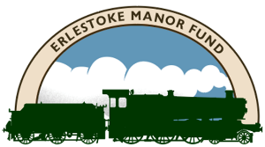
HELP ME GET MY GREAT WESTERN BARK BACK
2026 PRIZE DRAW
Part of the “Big Large Prairie Appeal” to bring No. 5164 back into service by 2030
Sponsorship with Prize Draw:
- This appeal will run through to 31 December 2026 to raise funds for that work to restore that popular Great Western "bark" to 5164! and is open to all aged 18 or over.
- Each sponsorship amount of at least £50 will give one entry into our prize draw to be drawn on the last day of the SVR Winter Steam Gala in early January 2027. So, £300 sponsorship would earn 6 entries and so forth.
- If not already an existing Shareholder, sponsors making payment of the minimum £50 will be enrolled as Shareholders in the Erlestoke Manor Fund, entitling them to an invite to a 5164 hauled special train following return to service, along with invites to the AGM, wider EMF events and volunteering opportunities.
- Recognition of being a 5164 supporter will be included, only with sponsor approval, on the EMF website.
Prizes for the Draw:
- 1st Prize - O Gauge Model of 5164
- 2nd Prize - Ticket for two on a Shakespeare Express run by Vintage Trains in 2027
- 3rd Prize - Weekend Gala Ticket for one of the SVR 2027 Galas
Raffle/Lottery Licence has been applied for.
Items which can be sponsored:
For 2026, there are two essential additional areas where there is an opportunity to progress if funding can be secured:
- We know that the pistons, cylinder bores, valve sleeves and piston valves are worn out - but fortunately can be brought back to new condition with some expenditure and physical work, restoring the popular Great Western "bark" to 5164 in the process!
- The coupling draw hooks are worn and require replacement. A number of locomotive groups are intending to place a bulk order for these in 2026, in order to obtain favourable discounting. If funding is available, the EMF would be in a position to join this initiative, saving a significant amount compared to a later one-off order.
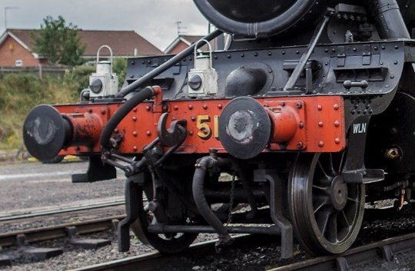
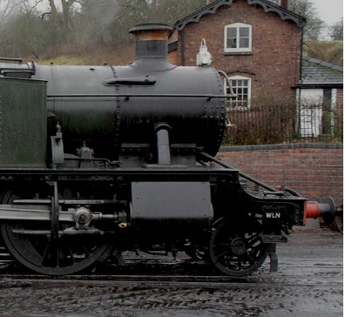

PISTON & VALVE SPONSORSHIP ITEMS COUPLING DRAW HOOK SPONSORSHIP ITEM
PLEASE SEE OVERLEAF
PLEASE SEE OVERLEAF
Please complete, scan and return this form by email to peterevans3105@outlook.com or by post to P Evans, EMF, Iona Chequers Lane, Wychbold, Droitwich Spa, Worcs. WR9 7PH
Item Description | No. of Items for Sponsorship | Cost Per Item | Amount of Sponsorship  £ (Min £50)
Piston Ring | 4 | £150
Piston Head Casting | 2 | £600
Piston Valve Sleeve | 4 | £2250
Piston Valve Snap Ring | 8 | £325
Piston Valve Wide Ring | 4 | £300
Piston Valve Wall Ring | 4 | £325
Piston Valve Wedge Ring | 8 | £425
Front Coupling Draw Hook | 1 | £3,200
Rear Coupling Draw Hook | 1 | £3,200

Full Name (Block Capitals): _______________________________________________________
Address & Post Code: ___________________________________________________________
_____________________________________________________________________________
Email: _________________________________________________________
Payment can be made by BACS to the details below:
Sort Code 53-81-21 account number 08716153 in the name of ErlestokeFD, using your SURNAME with initial / Bark as reference.
Cheques should be made payable to Erlestoke Manor Fund and sent with a covering note to the above address.

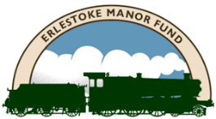
https://www.erlestokemanorfund.co.uk/
Erlestoke Manor Fund is a Charitable Community Benefit Society, Reg No. 7765.
Registered Office: 1-3 College Yard, Worcester WR1 2LB

